**Lesson 14 Cíntia Domingos**

**Beet Seed**

**3.**

There is a difference in the fonts between Mozilla Firefox 123.0 (64-bit) and Google Chrome Version 122.0.6261.95 (Official Build) (64-bit).

* Header “What is Permaculture?” should have the font “Century Gothic”

Mozilla: Changed to “Times New Roman”

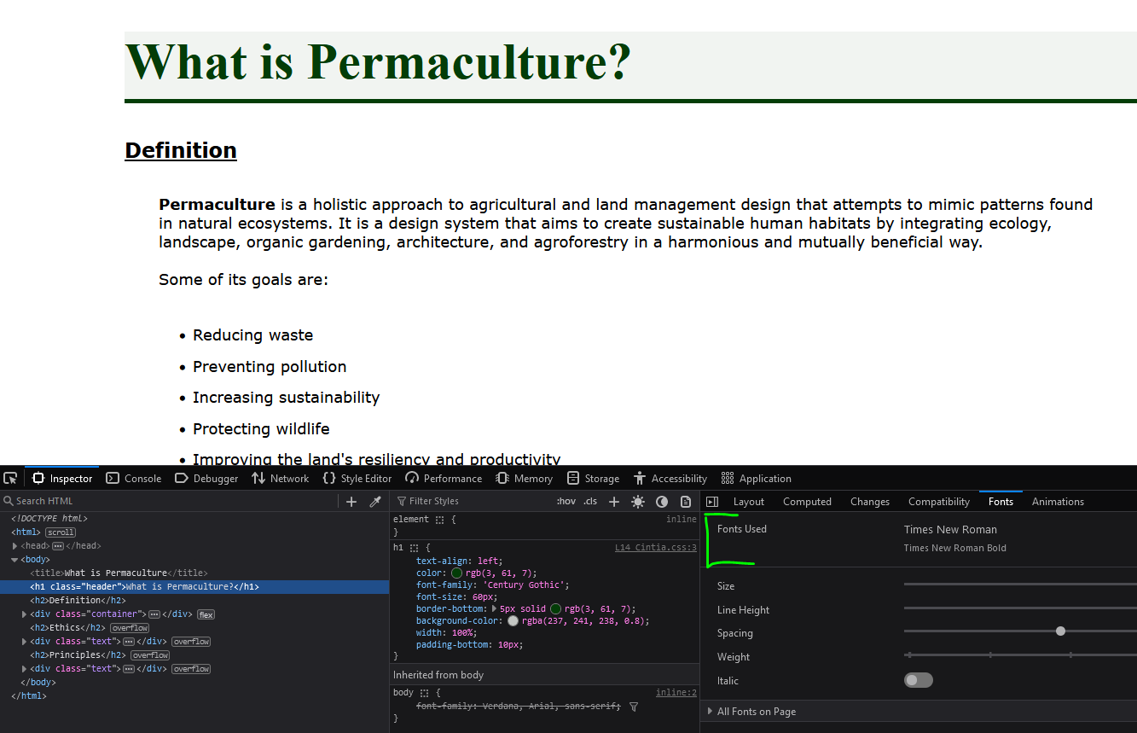

Chrome: OK

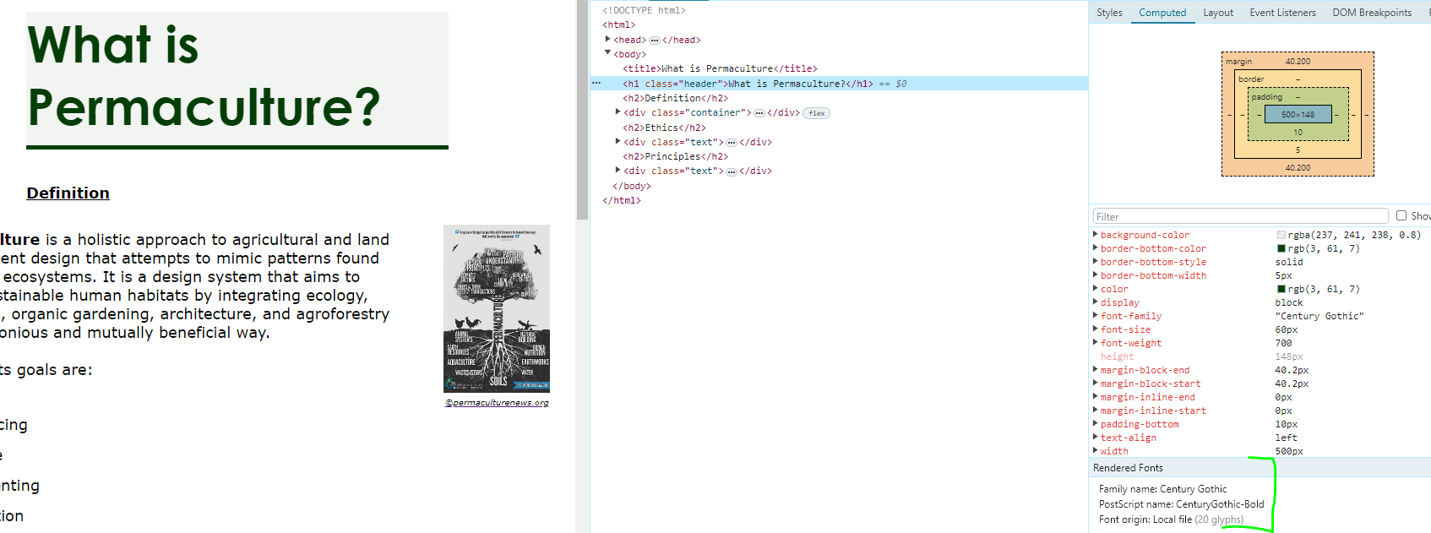

* Subheaders “Definition”, “Ethics” and “Principles”: font size was not set. It is shown as 24px for Mozilla and 18px for Chrome.

Mozilla:

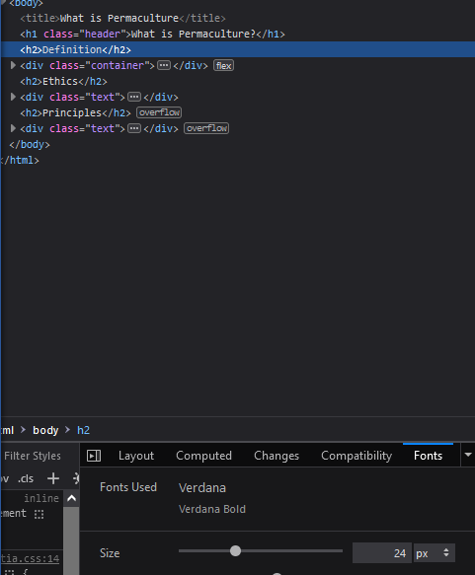

Chrome:

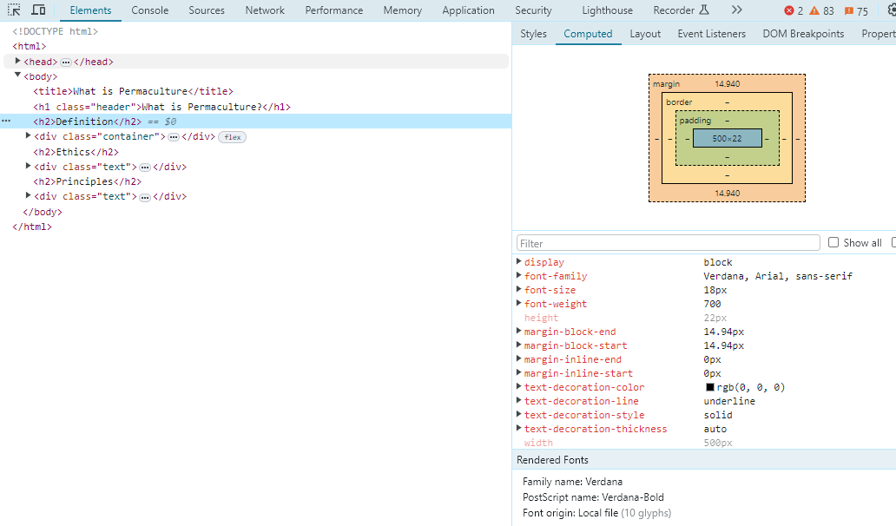

**Beet Sprout**

**2.1.** UTF-8

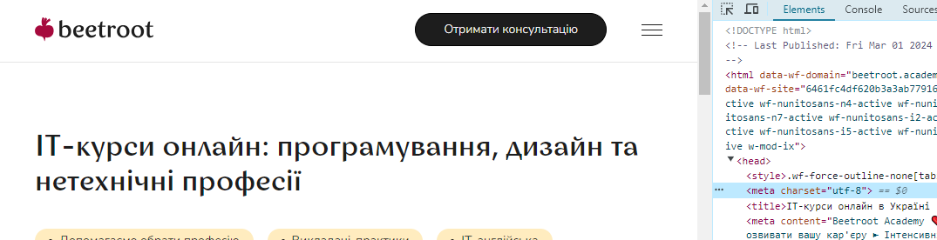

**2.2.** ISO-8859-1

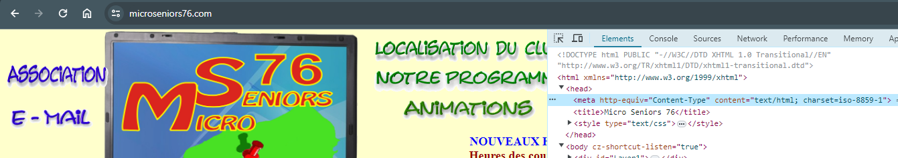

**2.3.** I found <meta charset="macintosh"> and <meta charset="utf-8">

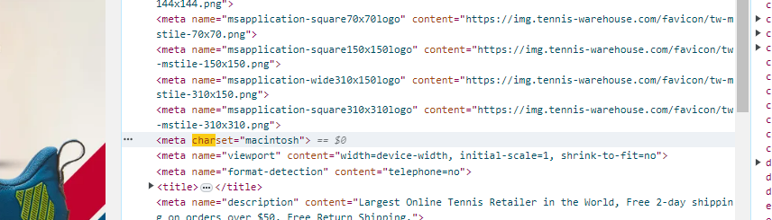

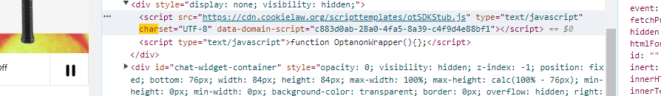

**2.4.** ISO-8859-1 and UTF-8

